The Executive Engineer
Kashmir Power Distribution Corporation Limited (KPDCL)
ED-II, Rajbagh, Srinagar

No: KGP/Estt/2025-26/715-716 Dated:26-07-2025

Subject: Request for Time Extension to Clear Outstanding Electricity Bill Liability.

Sir/Madam,

With reference to the outstanding electricity bill liability of approximately ₹20 lakhs owed by Kashmir Govt. Polytechnic College, Gogji Bagh, Srinagar, we wish to inform you that necessary steps have been taken to address this matter. A formal request for the release of funds was submitted to the Office of the Director, Skill Development Department, Government of Jammu & Kashmir, vide our letter Ref: KGP/Estt/2025-26/510-512,dated 02-07-2025. Additionally, a reminder letter was sent to the Director vide this office letter Ref: KGP/Estt/2025-26/713-714,dated 26-07-2025, urging the prompt release of funds. Copies of both letters are enclosed for your reference.
We are expecting the funds to be disbursed soon, and upon receipt, the outstanding payment will be promptly cleared with KPDCL. In view of these efforts, we kindly request your support in granting a reasonable extension of time to prevent any disconnection of the electricity service line to our institution. This extension is crucial to ensure the uninterrupted functioning of our academic and administrative operations, which directly impact our students and staff.

Yours Faithfully
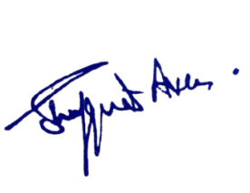
Enclosures:
1.Letter No:KGP/Estt/2025-26/5/510-512.
2.Letter No:KGP/Estt/2025-26/713-714.

Principal
Kashmir Government Polytechnic College
Srinagar
Copy to the:
1. Chief Engineer, KPDCL for information.

